Section 1 to Section 2 GIT

Link slides: [Git & Github: Intro To Git (canva.com)](https://www.canva.com/design/DAETQyFE6pM/mLt1oYF8gP_mqBS3ghb-BA/view?utm_content=DAETQyFE6pM&utm_campaign=designshare&utm_medium=link&utm_source=sharebutton#42)

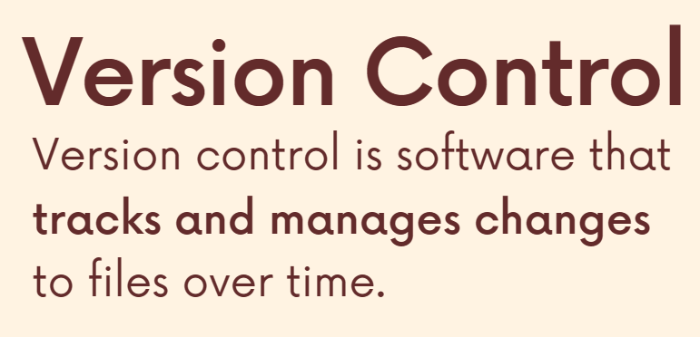

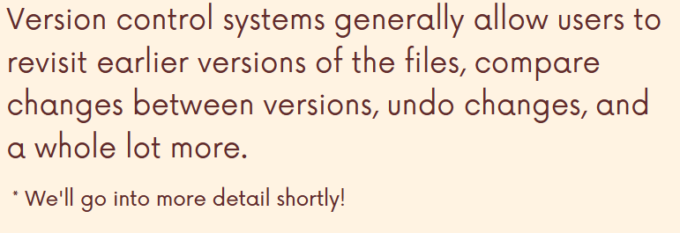

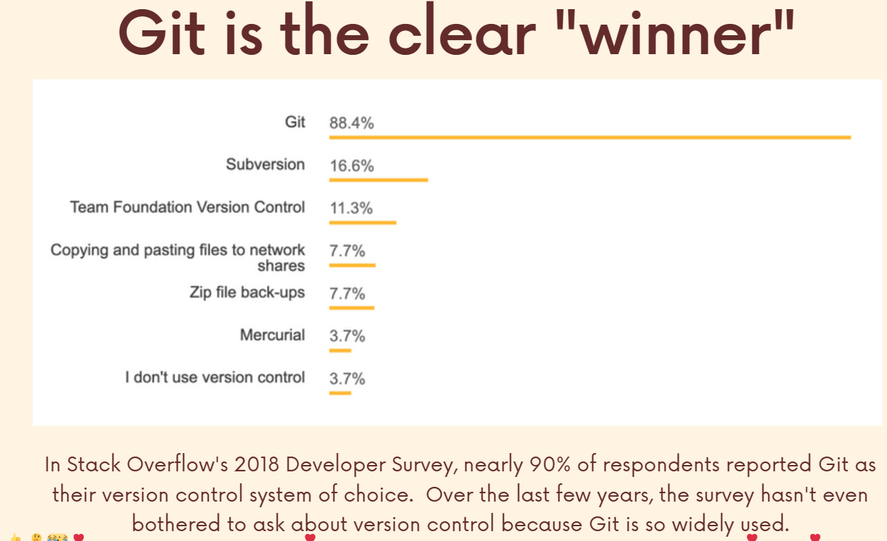

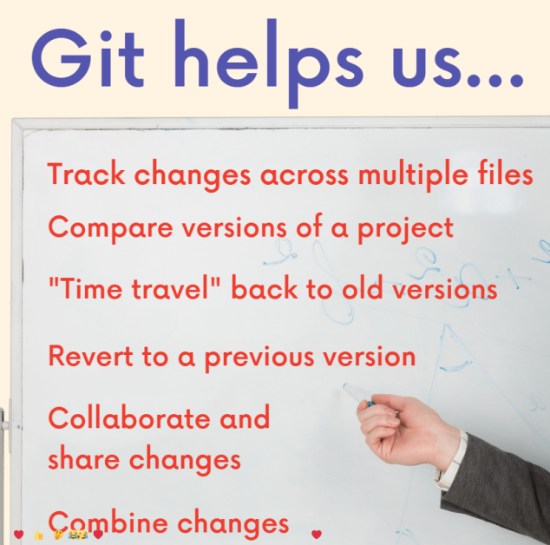

History of git (check link above)

Diferent Git and GitHub

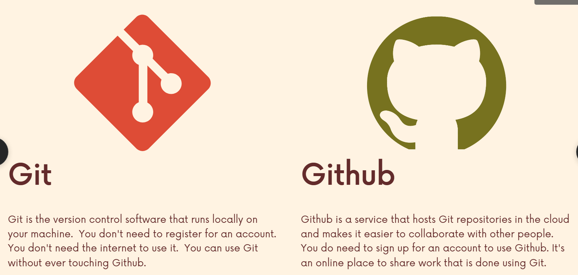

Section 3 installing git

Link slide: [Git & Github: Installation (canva.com)](https://www.canva.com/design/DAEXMu7dx04/x1kkoUK-g_j6UtObmUwbDA/view?utm_content=DAEXMu7dx04&utm_campaign=designshare&utm_medium=link&utm_source=sharebutton)

Link Git Gui client: [Git - GUI Clients (git-scm.com)](https://git-scm.com/downloads/guis)

You can use git gui, but command line is recommend

Windows install

[Git - Downloading Package (git-scm.com)](https://git-scm.com/download/win)

Then install visual studio code

Then check in cmd by command: git --version

15. Configuring your name and email

Step 1

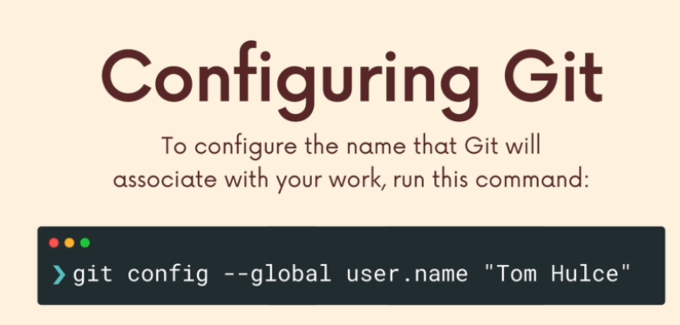

Step 2

Then check git config user.name

Step 3

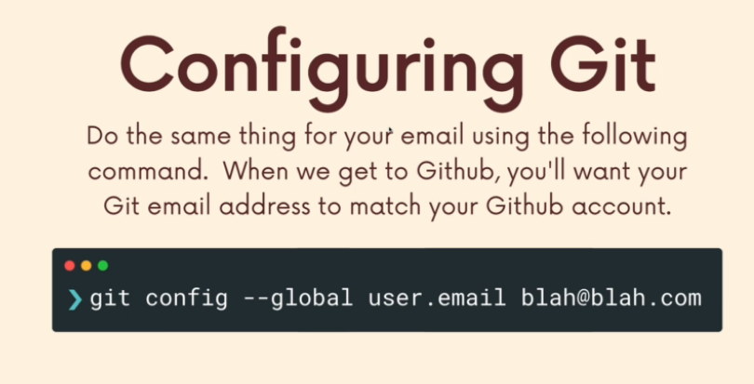

Step 4 check result by command

git config user.email

16. Install gitKraken

Link install: [Thank You for Downloading GitKraken](https://www.gitkraken.com/download/windows64)

18 Terminal crash course

LS

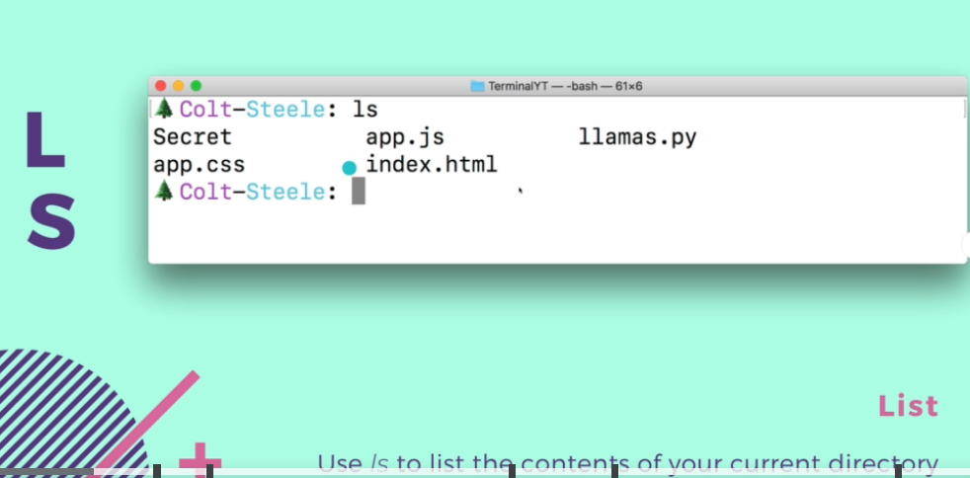

And also ls <nameFolder>

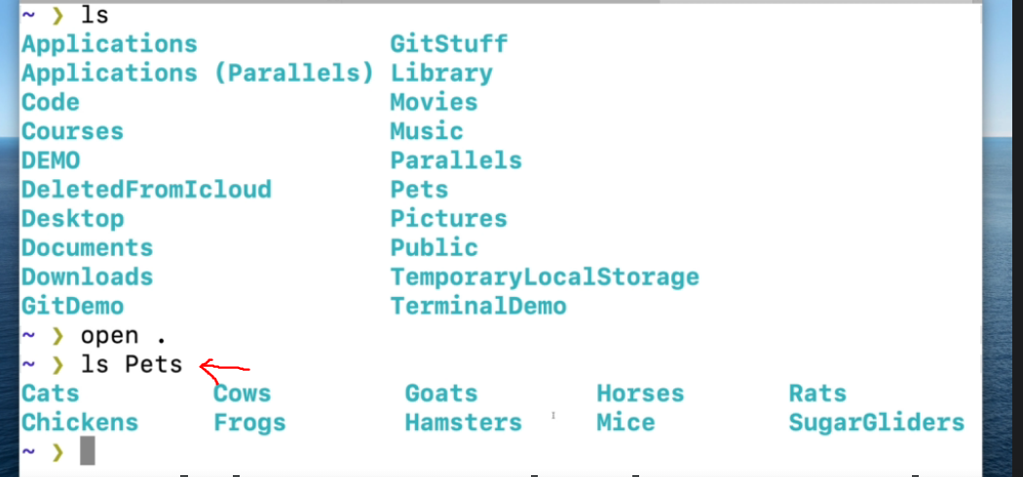

Another example

Ls Pets/Cats

If you Use command in git bash to open folder use command: start .

If you use cmd use command: open .

PWD

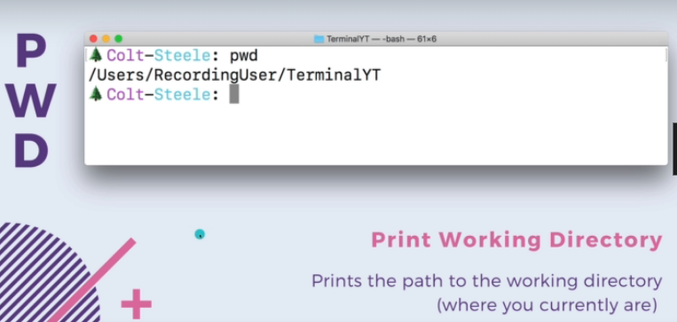

CD

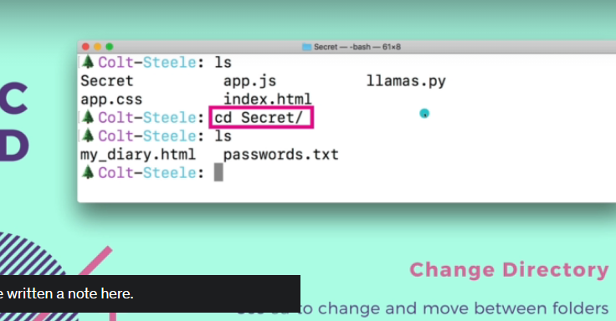

Use cd .. to back to one folder

Touch

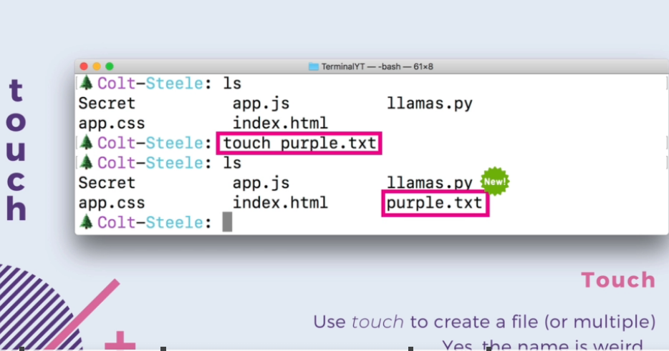

+ can also create multiple file

Mkdir

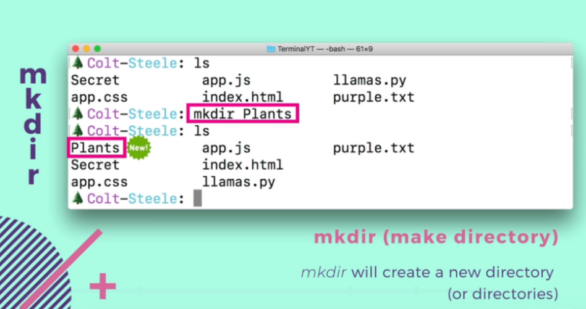

Or multiple file 

RM file

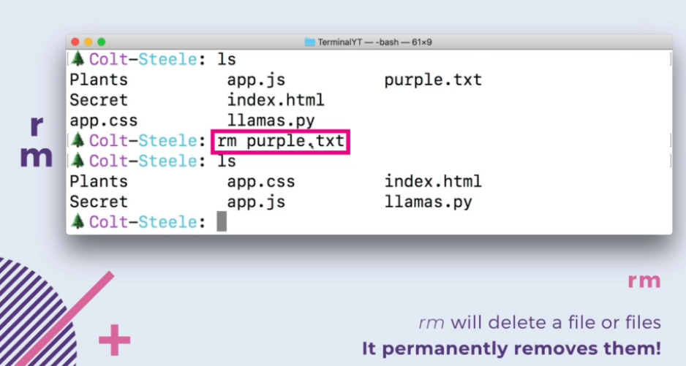

Or multiple file

RM folder

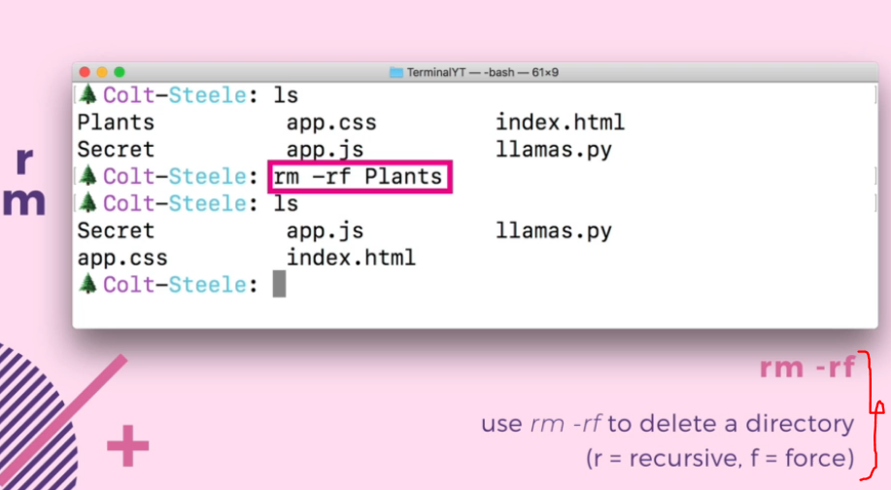

Section 4

Link slide: [Git & Github: Basics (canva.com)](https://www.canva.com/design/DAEPH_Lq4Wk/Wp_d5Rvk_OjVvgPH0xmzhg/view?utm_content=DAEPH_Lq4Wk&utm_campaign=designshare&utm_medium=link&utm_source=sharebutton)

22. What is git repo

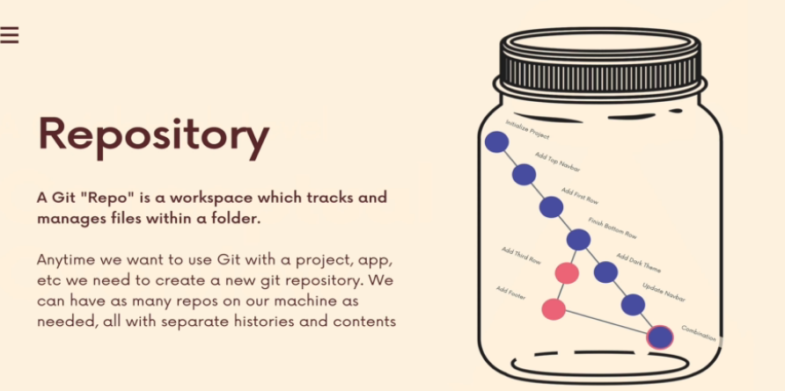

23. Git status

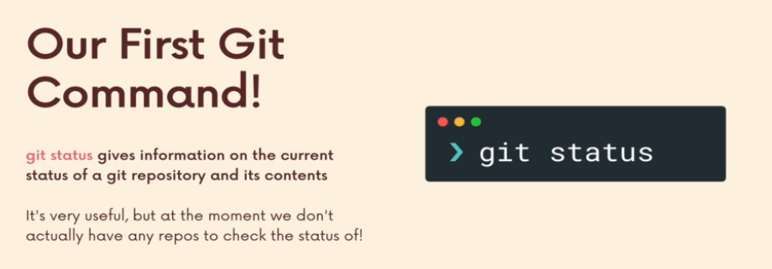

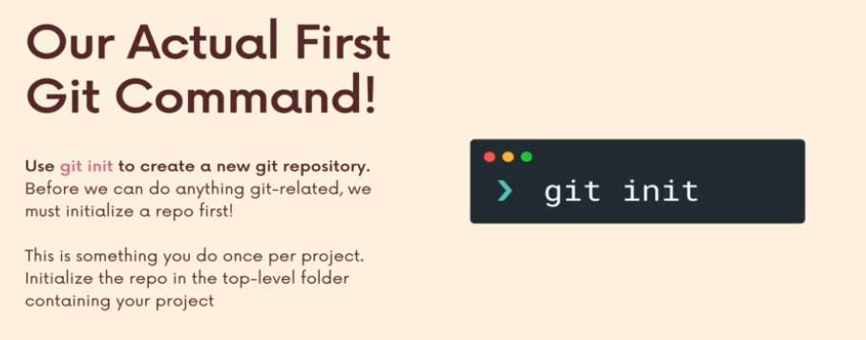

Warning git mistake

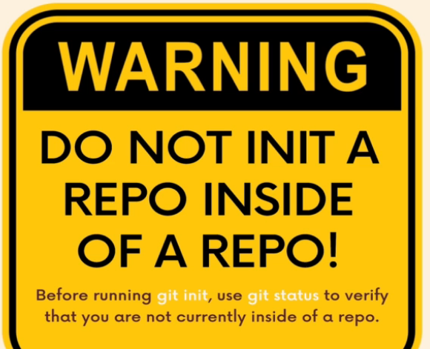

26. The Committing Workflow Overview

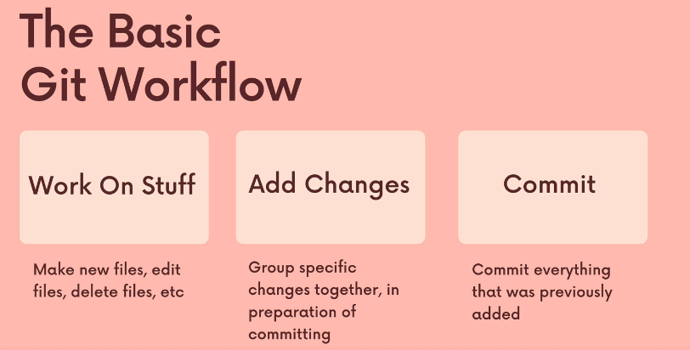

GIT ADD

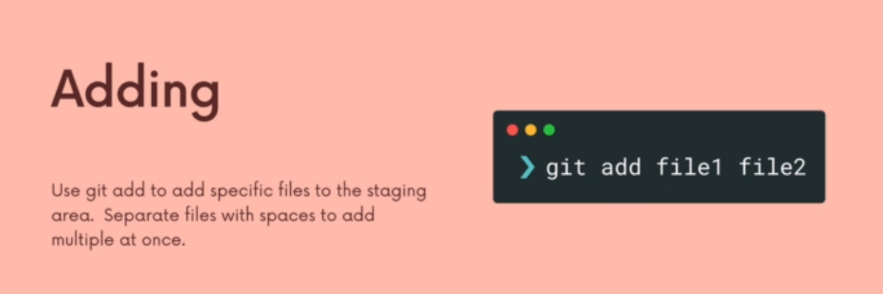

Step 1

Work on stuff

Create folder and file example

Step 2 Add Changes

Then check

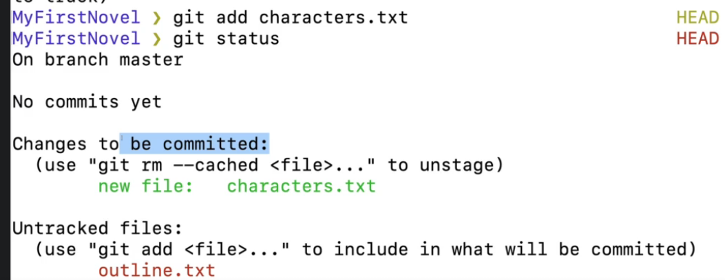

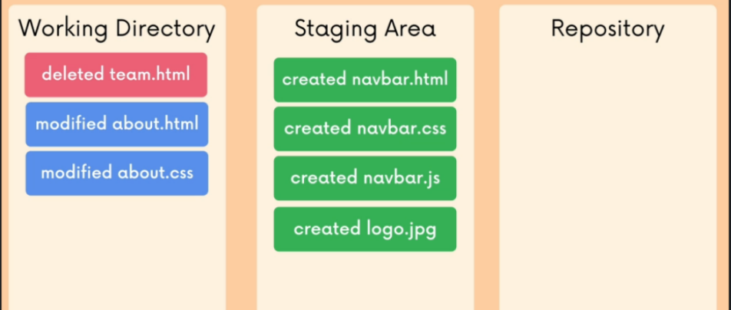

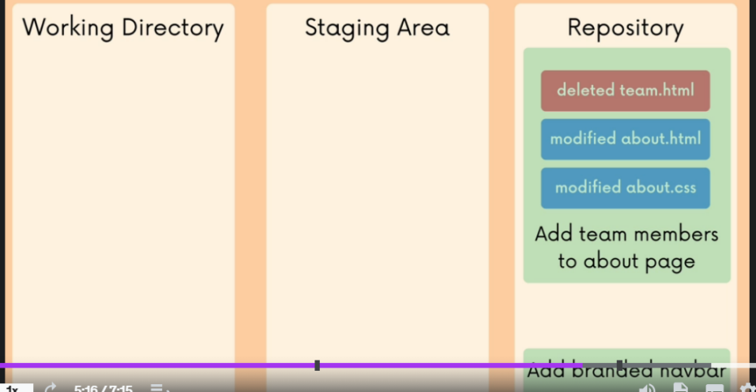

GIT COMMIT

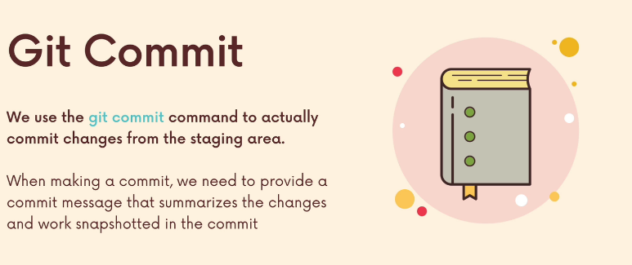

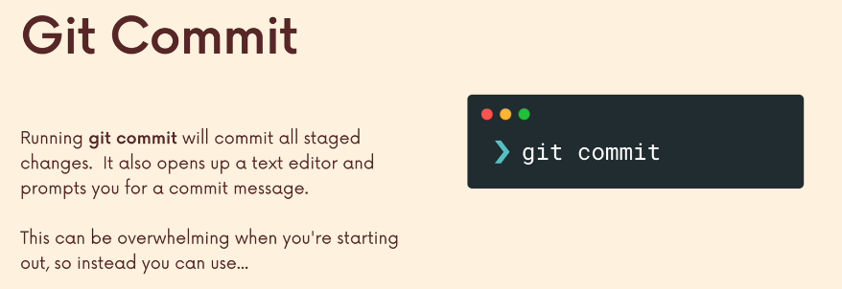

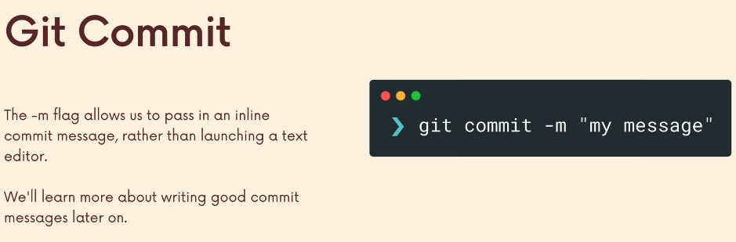

GIT LOG

Use command show history commit: git log

Exercise

[Committing Basics Exercise (notion.so)](https://www.notion.so/Committing-Basics-Exercise-3dc1ef1873ce45e68cedd2265710d7d8)

Section 5 commit in detail

Git Doc

[Git - Reference (git-scm.com)](https://git-scm.com/docs)

33 .Commit atomic

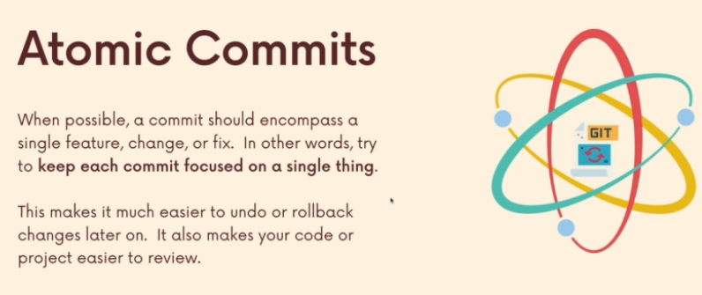

Don’t use git add . when you have a lot of feature in one branch, because if you want rollback it will make easy

35 Config git default editor (allow add big message when commit)

[Git - Setup and Config (git-scm.com)](https://git-scm.com/book/en/v2/Appendix-C%3A-Git-Commands-Setup-and-Config)

Example in visual studio code

Step 1 in studio code run   
git config --global core.editor "code --wait"

Step 2 create new file example and commit file

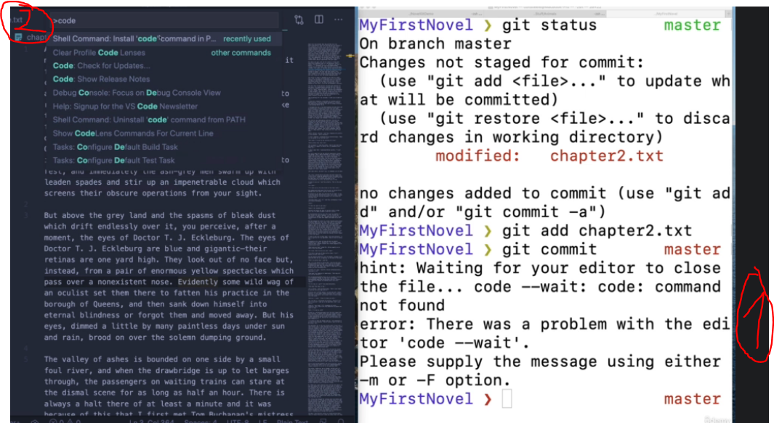

36. A Closert of git log

[Git - git-log Documentation (git-scm.com)](https://git-scm.com/docs/git-log)

Example run command to short message git: git log –oneline

36. Commit with a GUI

Use GitKrakenSetup to commit

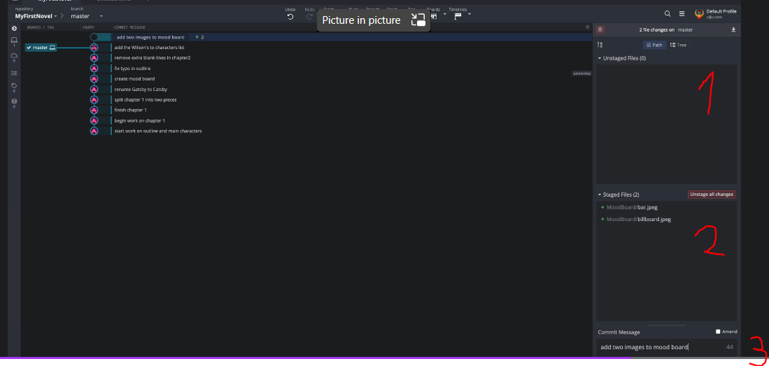

38. Fixing mistake with amend

[Git - git-commit Documentation (git-scm.com)](https://git-scm.com/docs/git-commit)

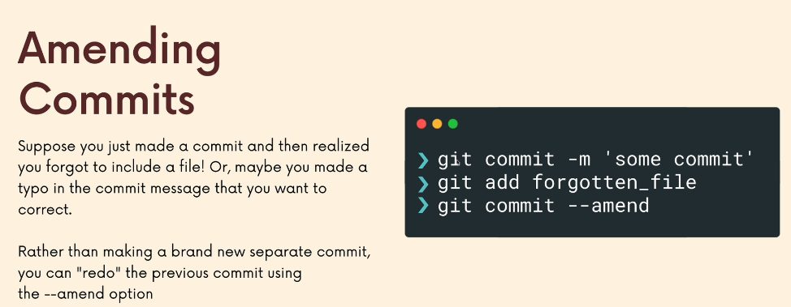

Use amend when you forgot add file, when you had commed

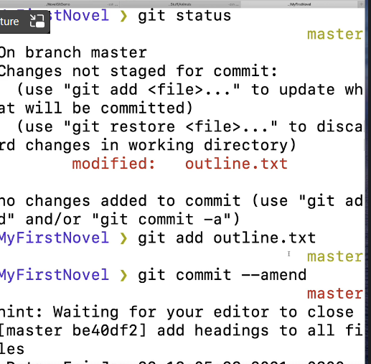

39. Ignore file gitinore

[gitignore.io - Create Useful .gitignore Files For Your Project (toptal.com)](https://www.toptal.com/developers/gitignore)

[Ignoring files - GitHub Docs](https://docs.github.com/en/get-started/getting-started-with-git/ignoring-files)

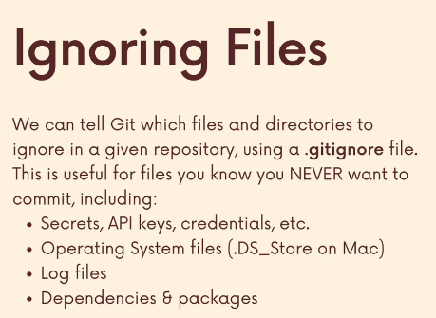

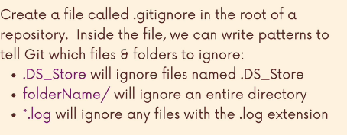

Step 1 create new “touch .gitinore” then

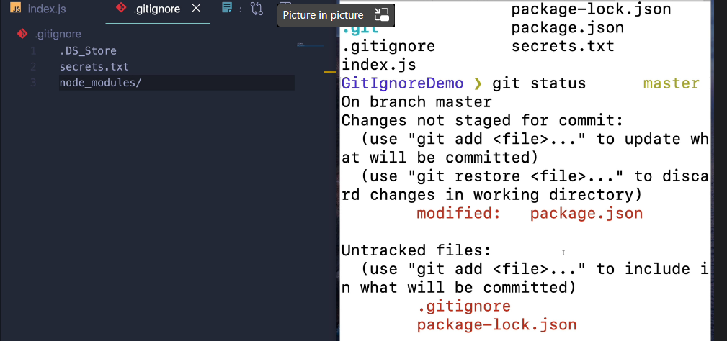

Section 6: Working with branch